Names:

- What happen when the power of the base station is increased? Which radio links are affected?

- What happen when the power of either a mobile or handheld/portable phone are decreased? Which radio links are affected?

- What happen when the receivers (Base Station, mobile or handheld/portable phone) have higher sensitivity?

- Once you have calculate the maximum admissible power losses for each case (link power budget in excel datasheet), calculate the equivalent range based on the free space model (basic propagation losses). Which does this range mean (physical sense of this range)?

L_{bas}(dB) = 92,45 + 20 log₁₀ f(GHz) + 20 log₁₀ r(km)

Worst Case STATIC

Base Station ←→ Mobile (Max Losses: ______ dB ). Range:__________ km

Base Station ←→ Portable (Max Losses: ______ dB ). Range:__________ km

Worst Cases DYNAMIC:

Base Station ←→ Mobile (Max Losses: ______ dB). Range:__________ km

Base Station ←→ Portable (Max Losses: ______ dB). Range:__________ km

- If the receiver were placed at 10 km from the transmitter, which Fade Margin (MF) for every link would be? Please consider Free Space Losses for all cases.

Free Space Losses (10 km) = _____________(dB) (from Equation)

Worst Case STATIC

Base Station ←→ Mobile (Max Losses: ______ dB ). Fade Margin:_________ dB

Base Station ←→ Portable (Max Losses: ______ dB ). Fade Margin:_________ dB

Worst Cases DYNAMIC:

Base Station ←→ Mobile (Max Losses: ______ dB). Fade Margin:_________ dB

Base Station ←→ Portable (Max Losses: ______ dB). Fade Margin:_________ dB

- If the selected propagation losses model were Suburban Okumura, and the height of the Base Station and the portable were 30 m and 1.5 m, respectively, calculate again the Fade of Margin for all cases here below:

Okumura Suburban Losses (10 km) = _____________(dB) (from either the figure or web link provided).

Worst Case STATIC

Base Station ←→ Mobile (Max Losses: ______ dB ). Fade Margin:_________ dB

Base Station ←→ Portable (Max Losses: ______ dB ). Fade Margin:_________ dB

Worst Cases DYNAMIC:

Base Station ←→ Mobile (Max Losses: ______ dB). Fade Margin:_________ dB

Base Station ←→ Portable (Max Losses: ______ dB). Fade Margin:_________ dB

Attachment:

Please see web link: http://www.cdt21.com/resources/siryo4.asp

Okumura Hata Formulae:

Approximation conditions:
Frequency: 150MHz - 1500MHz
Communication range: 1Km - 20Km
Base station antenna height: 30m - 200m
Mobile station antenna height: 1m - 10m
Approximation
Here A and B are the same for each area. a(hm) and C have different values for each area.
Furthermore, in large cities, the a(hm) value differs according to whether the working frequency is above or below 400 MHz.
Parameters

< Common to all areas >
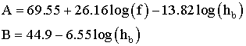
<Open land >
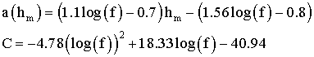

<Suburbs>
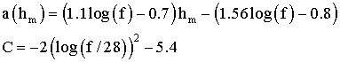
<Medium city
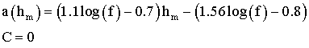
<Large city>
